**Project Part 4 - 85 points total**

At this point your report should have a title page, a proposal which summarizes your project and network architecture, and descriptions of your entities and attributes. Your GitHub should have your ERD file and 10 data files containing 3 entries each for 5 entities in both CSV and XML format.  
  
Next your project will exercise your use of SQL commands by requiring you to create databases, load your data files into the databases, and then perform a few exercises. Finally, address the thought exercise at the end.

**TO GET CREDIT:**

**1.** Take screen captures of the results to prove that your command did what it needed to do. More specifically, show a ‘before” picture, then an ‘after’ picture with your command in the middle. A simple status message of ‘ok’ is NOT acceptable.   
  
**2.** Perform these actions on MariaDB in Linux, or a mySQL-compatible system. Remember, I need to test these commands.

**3.** Include part of your desktop as evidence that you did this work yourself. For example, here is one I might do:

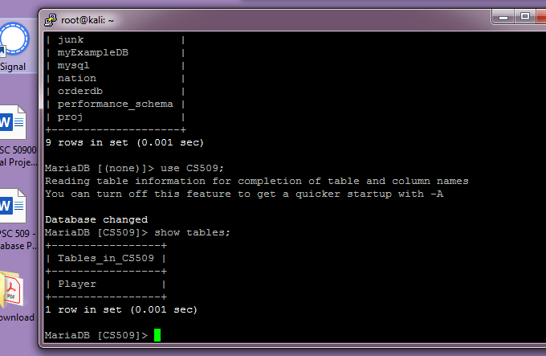

It isn’t a real ‘before/after’ example, but it shows data before I issued a command, it shows the command, and then it shows the results afterward. You can also see my desktop off to the side, and expect to see it in all future screen captures.

**SECTION 1**

**Data Definition Language Scripts**

For this segment of the project you must write SQL commands to create your database tables and then load your data files into your tables. When you are finished, your database tables should contain all of the information that you described in your XML or CSV data sources. You may choose which 5 files you wish to load. I just need to see the script and the populated tables.

**Document** your work in your **report** by showing the script and screen captures of the results.

The screen captures must show the contents of the database matching your design and the contents of your data files.

Also, save your scripts (table creation and loading command) to a text file that ends with the .sql extension, and save your script file to GitHub. Please consult the rubric for full details about what is expected in the report.

* SQL script that creates and populates your tables saved as an sql script file (this is a simple text file with a .sql extention). Upload to GitHub. 8 points

**Ans:**

* Copy the script in your report. 2 points

**Ans: CREATE TABLE `Customer_details` (**

**`customer_id` VARCHAR(25) NULL,**

**`customer_name` VARCHAR(25) NULL,**

**`customer_address` VARCHAR(25) NULL,**

**`phone_number` VARCHAR(25) NULL**

**);**

**LOAD DATA LOW_PRIORITY LOCAL INFILE 'C:\\Users\\admin\\OneDrive\\Desktop\\Customer_details.csv' REPLACE INTO TABLE `tea`.`customer_details` CHARACTER SET latin1 FIELDS TERMINATED BY ',' OPTIONALLY ENCLOSED BY ',' ESCAPED BY ',' LINES TERMINATED BY '\r\n' IGNORE 1 LINES (`customer_id`, `customer_name`, `customer_address`, `phone_number`);**

**CREATE TABLE `order_details` (**

**`order_id` VARCHAR(50) NULL DEFAULT NULL,**

**`order_date` DATE NULL,**

**`quantity` INT(15) NULL,**

**`price` INT(15) NULL,**

**`customer_id` VARCHAR(50) NULL DEFAULT NULL**

**);**

**LOAD DATA LOW_PRIORITY LOCAL INFILE 'C:\\Users\\admin\\OneDrive\\Desktop\\order_details.csv' REPLACE INTO TABLE `tea`.`order_details` CHARACTER SET latin1 FIELDS TERMINATED BY ',' OPTIONALLY ENCLOSED BY ',' ESCAPED BY ',' LINES TERMINATED BY '\r\n' IGNORE 1 LINES (`order_id`, `order_date`, `quantity`, `price`, `customer_id`);**

**CREATE TABLE `order_status` (**

**`order_status_id` VARCHAR(25) NULL DEFAULT NULL,**

**`order_id` VARCHAR(25) NULL DEFAULT NULL,**

**`process` VARCHAR(25) NULL DEFAULT NULL**

**);**

**LOAD DATA LOW_PRIORITY LOCAL INFILE 'C:\\Users\\admin\\OneDrive\\Desktop\\order_status.csv' REPLACE INTO TABLE `tea`.`order_status` CHARACTER SET latin1 FIELDS TERMINATED BY ',' OPTIONALLY ENCLOSED BY ',' ESCAPED BY ',' LINES TERMINATED BY '\r\n' IGNORE 1 LINES (`order_status_id`, `order_id`, `process`);**

**CREATE TABLE `payment` (**

**`payment_id` VARCHAR(25) NULL DEFAULT NULL,**

**`method` VARCHAR(25) NULL DEFAULT NULL,**

**`pay_status` VARCHAR(25) NULL DEFAULT NULL,**

**`amount` FLOAT NULL DEFAULT NULL,**

**`customer_id` VARCHAR(25) NULL DEFAULT NULL**

**);**

**LOAD DATA LOW_PRIORITY LOCAL INFILE 'C:\\Users\\admin\\OneDrive\\Desktop\\payment.csv' REPLACE INTO TABLE `tea`.`payment` CHARACTER SET latin1 FIELDS TERMINATED BY ',' OPTIONALLY ENCLOSED BY ',' ESCAPED BY ',' LINES TERMINATED BY '\r\n' IGNORE 1 LINES (`payment_id`, `method`, `pay_status`, `amount`, `customer_id`);**

**CREATE TABLE `review` (**

**`review_id` VARCHAR(54) NULL DEFAULT NULL,**

**`Customer_name` VARCHAR(45) NULL DEFAULT NULL,**

**`comment` VARCHAR(43) NULL DEFAULT NULL**

**);**

**LOAD DATA LOW_PRIORITY LOCAL INFILE 'C:\\Users\\admin\\OneDrive\\Desktop\\review.csv' REPLACE INTO TABLE `tea`.`review` CHARACTER SET latin1 FIELDS TERMINATED BY ',' OPTIONALLY ENCLOSED BY ',' ESCAPED BY ',' LINES TERMINATED BY '\r\n' IGNORE 1 LINES (`review_id`, `Customer_name`, `comment`);**

* Screenshots of your populated tables with at least three records from your data files: 10 points  
  The ‘before’ picture shows an empty table. If it helps, you can merge all images into one screen capture.

**Answer:**

**USE tea;**

**SELECT * FROM customer_details**

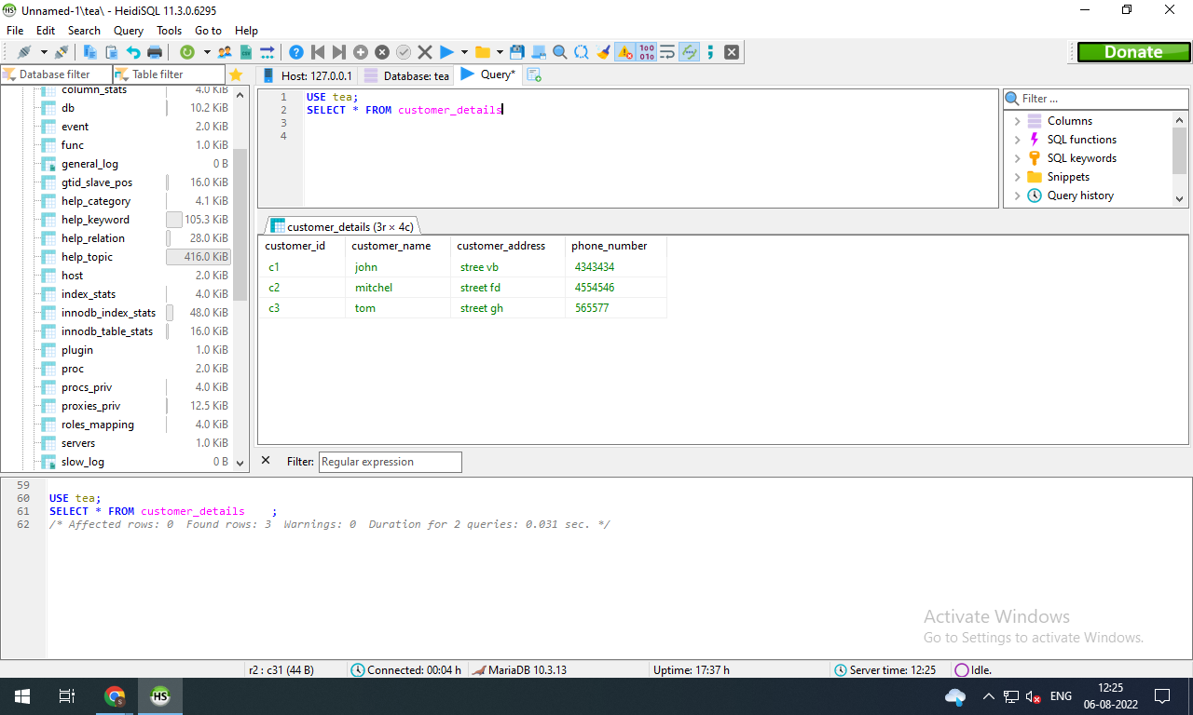

**USE tea;**

**SELECT \***

**FROM order_status**

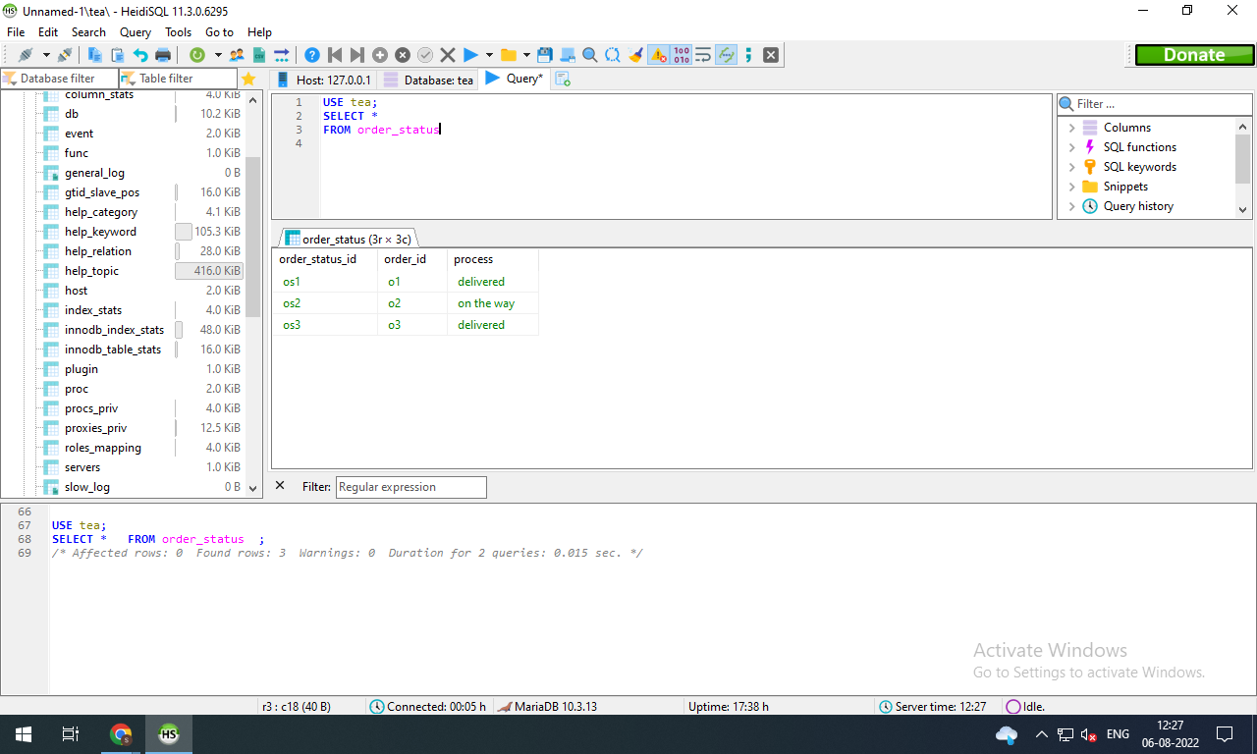

**USE tea;**

**SELECT * FROM order_details**

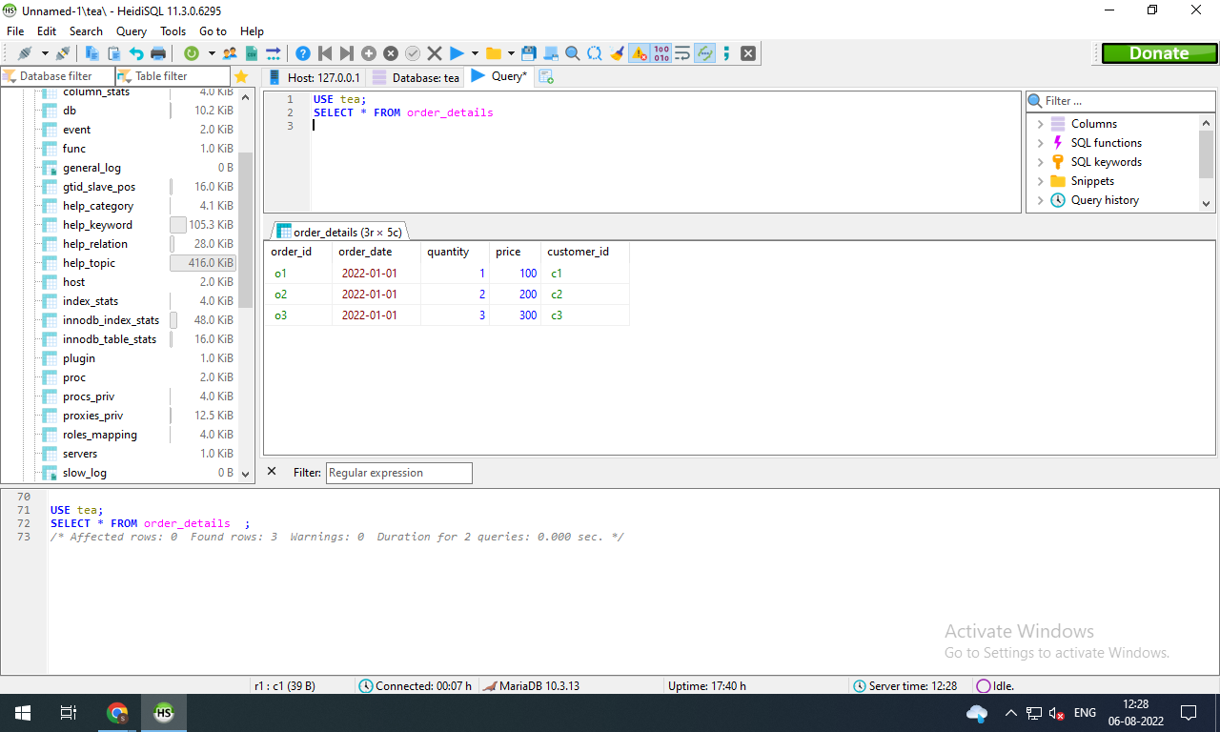

**USE tea;**

**SELECT * FROM payment**

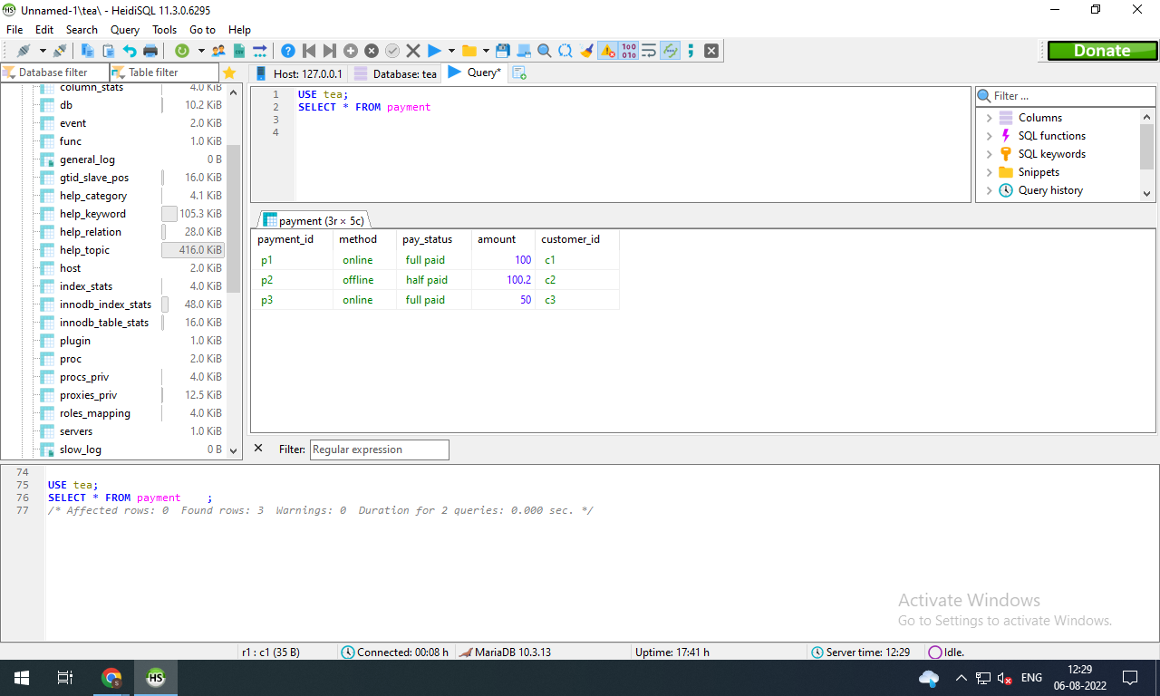

**USE tea;**

**SELECT * FROM review**

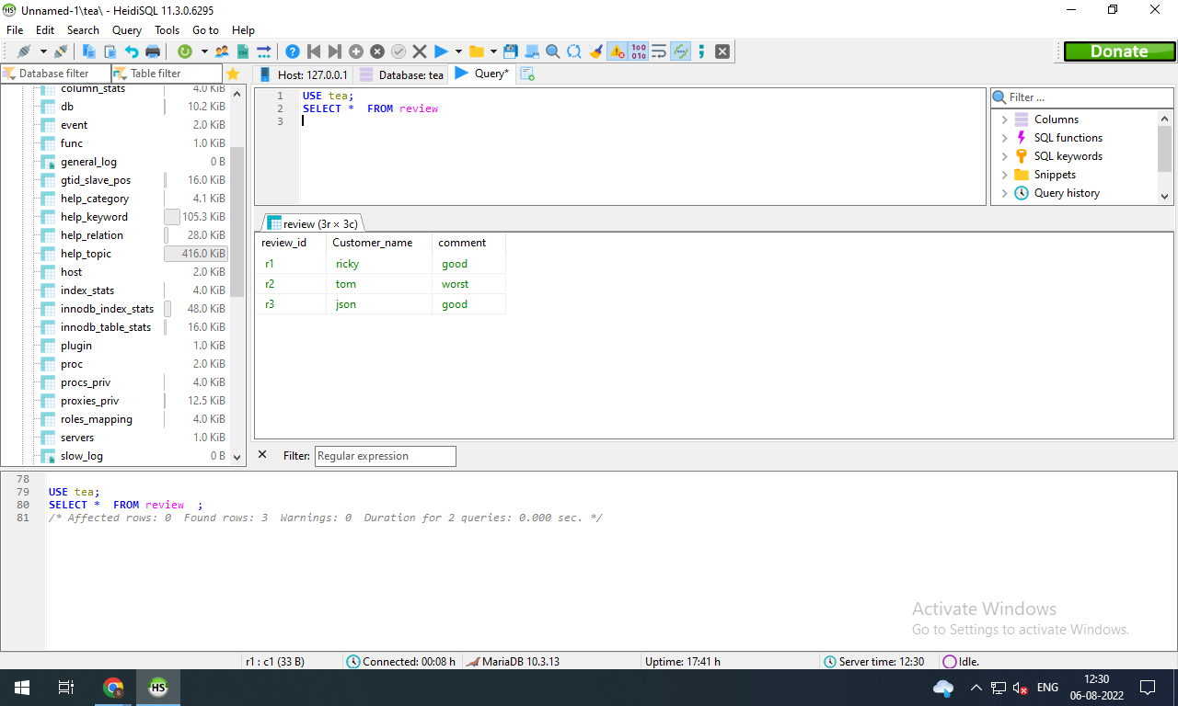

Total points possible: 20

**CHEAT/COMPLIANCE WARNING:**

If your document contains screen captures that are copies of other students’ captures in terms of image and data size, I will issue a 0. Also, use SQL that is compatible with mariaDB. If I cannot test your work, I will give you a 0.

**Tips to load your data files**

Now that you have the tables created, you must complete this section by loading your data files with a ‘load’ command.

TO IMPORT DATA INTO MariaDB:

1. Use “LOAD DATA LOCAL INFILE ‘filename’ “ to load a delimited Excel file (usually a comma separated value, CSV).

<https://mariadb.com/kb/en/load-data-infile/>

You’ll notice the ‘set’ at the end gives you the option to manipulate data during the load. In fact, nearly all of those commands are optional since they are shown within square brackets, [ ]. Thus, this step is very simple! You may also redefine the delimiter character if you are not using a CSV.

2. If you are using XML files to store data, then see this example:

<https://mariadb.com/kb/en/load-xml/>

Again, a single command will load the contents of your file.   
  
If you get an error like the file is missing, then you need to either find the active directory and copy the data files there, or else include the absolute path to your files as part of the file name when you do the ‘load’.

Example:  
#> LOAD DATA LOCAL INFILE ‘/home/matt/cs509/products.CSV’

**See second half on next page, worth 45 points**

**SECTION 2**

**Data Manipulation Language Scripts**

Write the SQL commands for twelve queries. Two queries should be insert statements, two should update statements, one should be a delete statement, one should be a simple select statement that selects a subset of the rows and columns from one table, two queries should be a select statements that select data from a joining of two tables, three queries should use summary functions to generate statistics about the data, and one query should be a multi-table query. Show the queries and screenshots of the results in your Word document **report**, and save your queries in a commented sql script to GitHub.

Rubric: Your work will be graded as follows:

* 1 point for one insert statement

**Ans**

**USE tea;**

**INSERT INTO customer_details(customer_id,customer_name,customer_address,phone_number)**

**VALUES('c4','jack','street o','43424')**

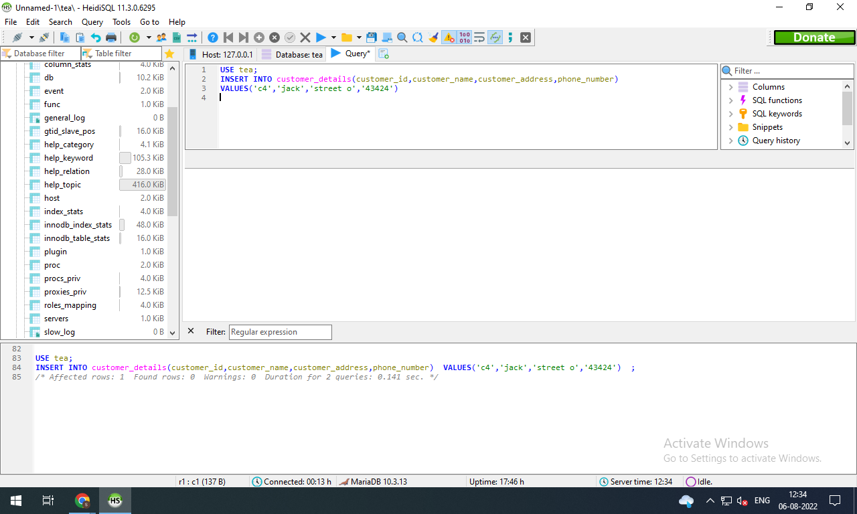

* 1 point for one update statement

**Ans: USE tea;**

**UPDATE customer_details**

**SET customer_name='jakey',customer_address='os street',phone_number='978978'**

**WHERE customer_id='c4';**

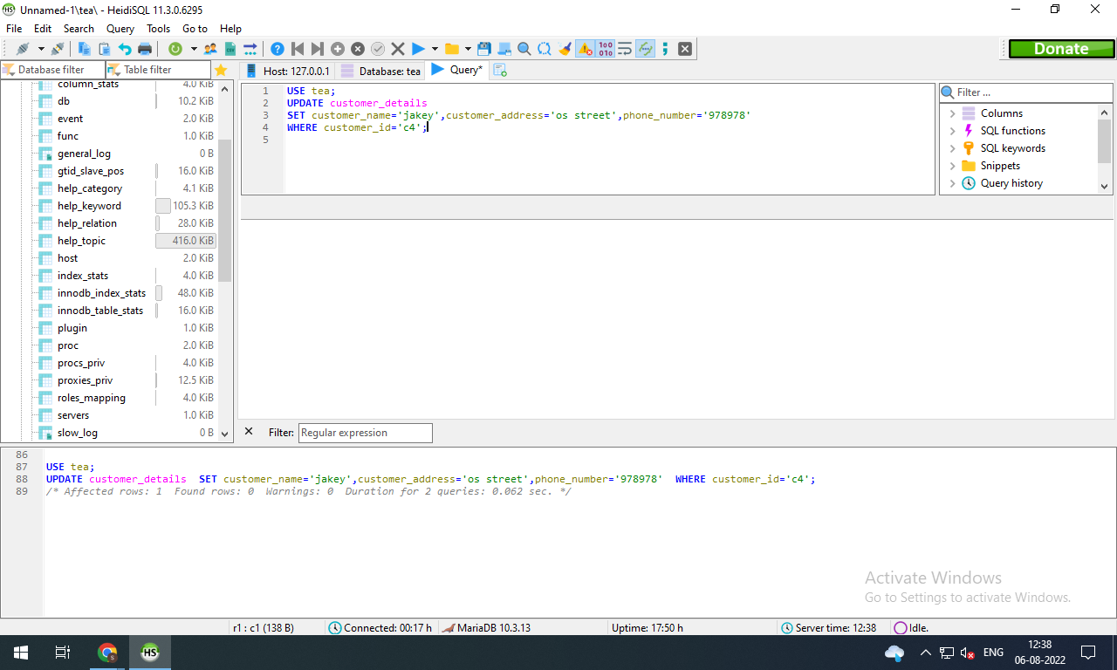

* 1 point for using the delete statement (1 pt)

**Ans: DELETE FROM customer_details WHERE customer_id='c4';**

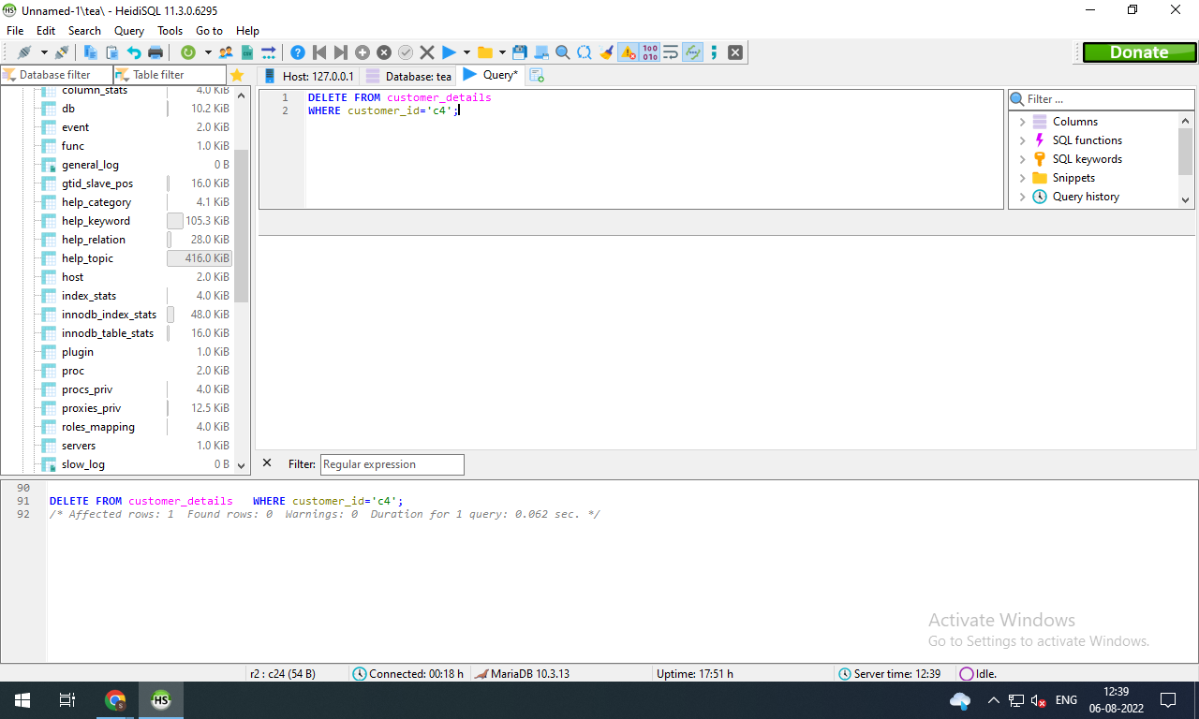

* 1 point for select with ORDER BY statement (1 pt)

**Ans:**

**USE tea;**

**SELECT order_id,order_date**

**FROM order_details**

**ORDER BY quantity ASC**

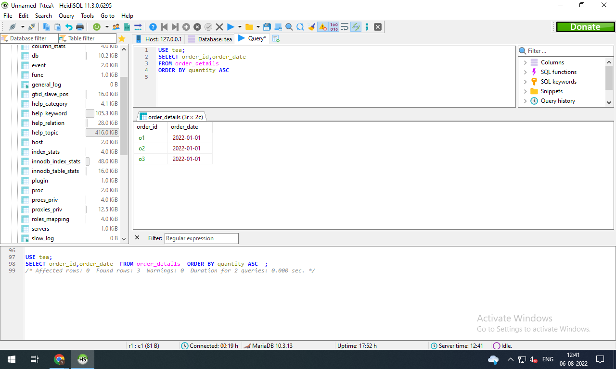

* 1 point for select with a filtering condition using ‘WHERE’

**Ans: USE tea;**

**SELECT customer_name**

**FROM review**

**WHERE comment='good';**

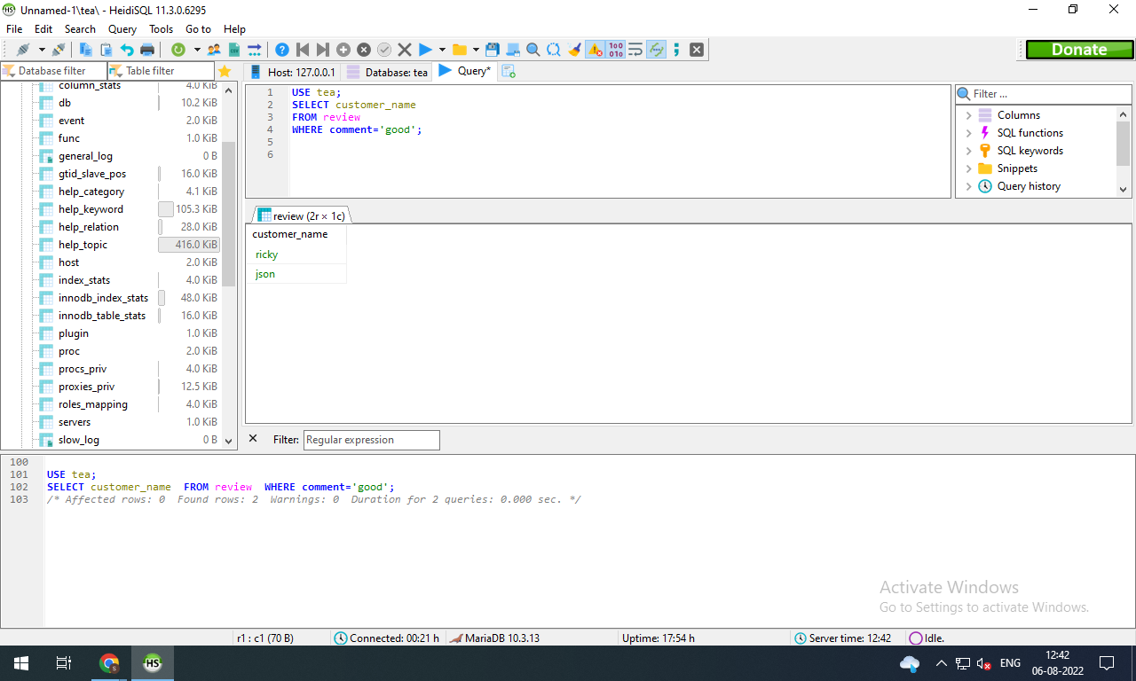

* 2 points for using the join statement

**Ans:**

**USE tea;**

**SELECT customer_details.customer_id,order_details.order_date**

**FROM customer_details**

**INNER JOIN order_details ON customer_details.customer_id=order_details.customer_id;**

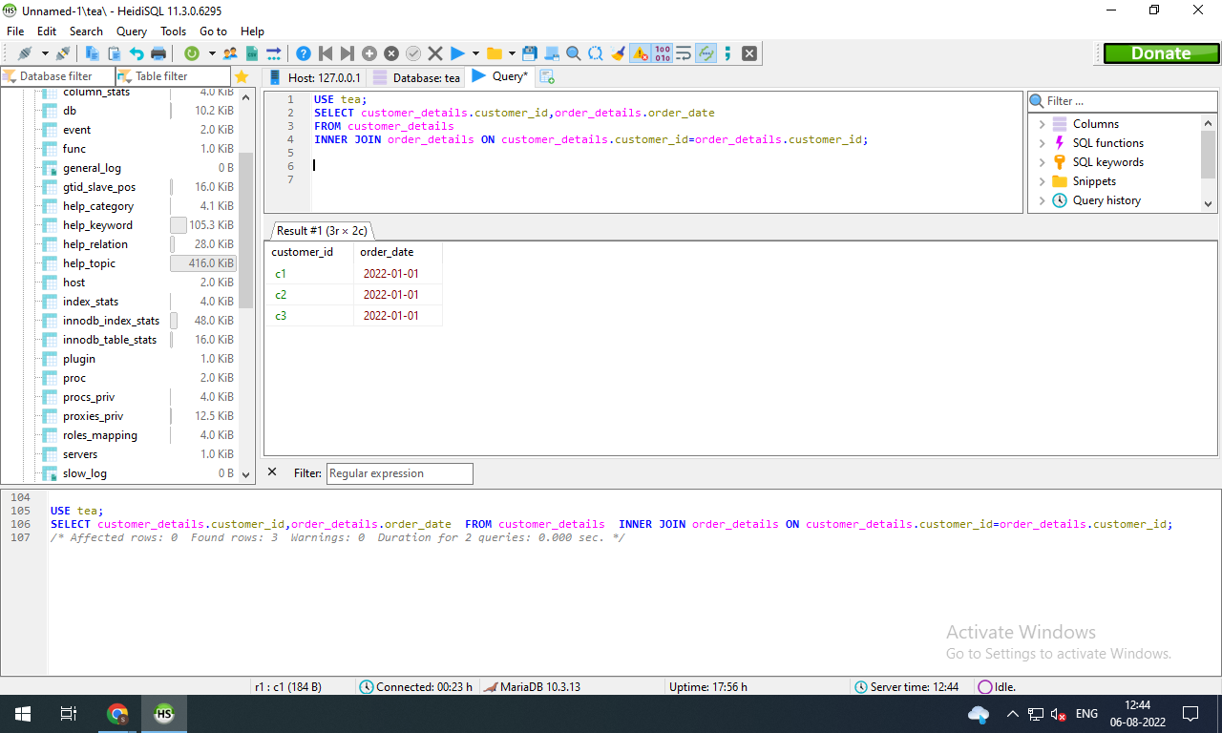

* 6 points each for three queries that use DIFFERENT summary statements (max, min, avg, count) (2 pts eachl)  
  You cannot use the same summary statement 3 times.

**Ans: USE tea;**

**SELECT MAX(price)**

**FROM order_details**

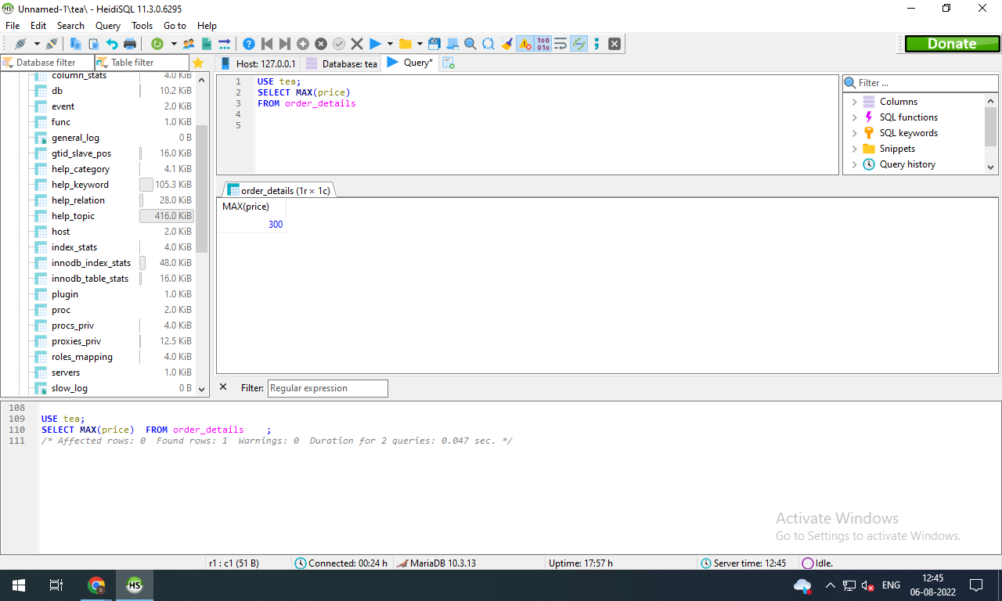

**USE tea;**

**SELECT MIN(quantity)**

**FROM order_details**

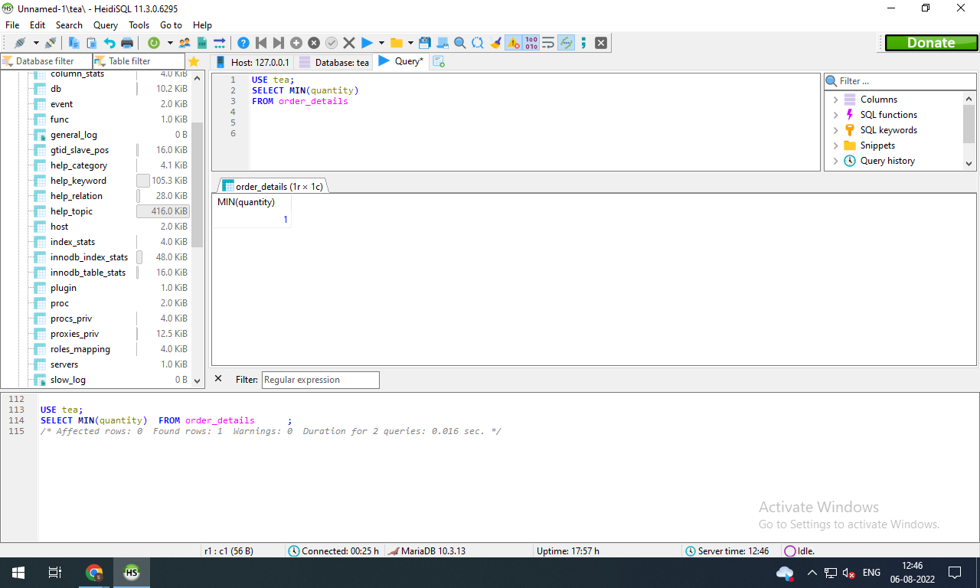

**USE tea;**

**SELECT AVG(amount)**

**FROM payment**

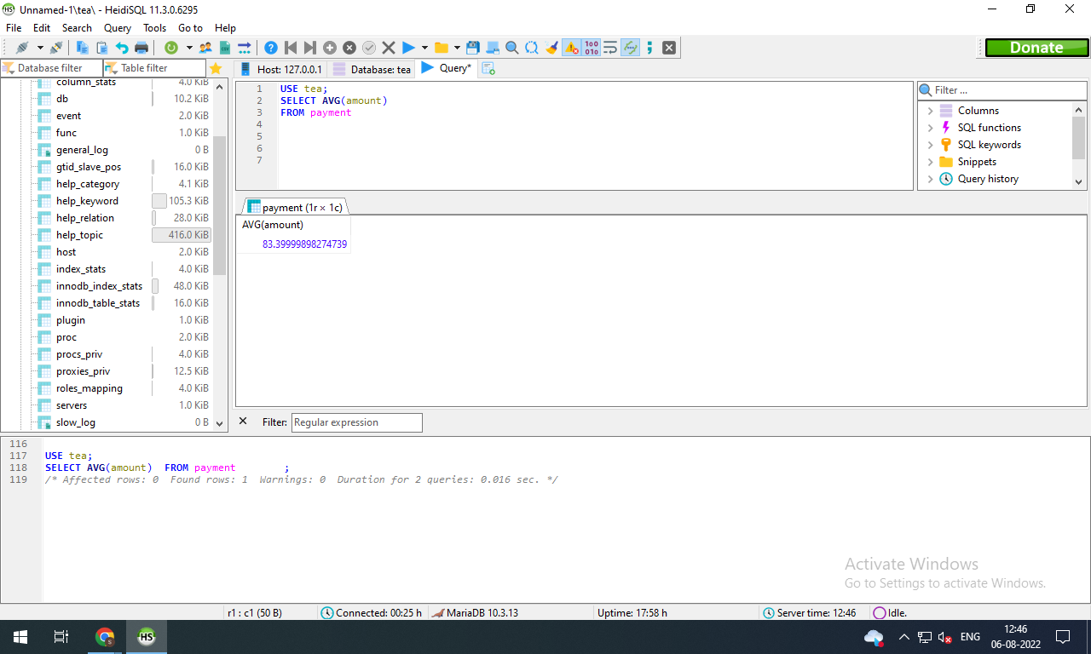

**USE tea;**

**SELECT COUNT(customer_id)**

**FROM payment**

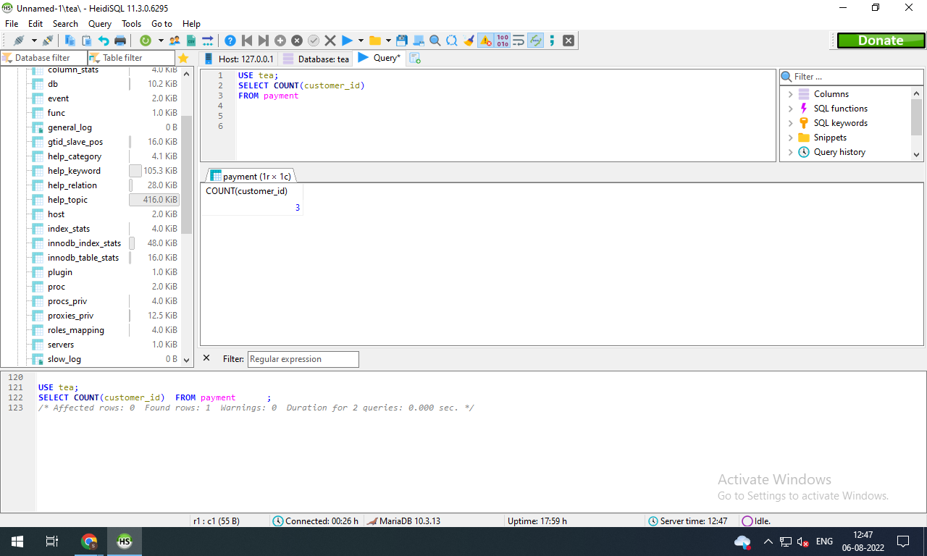

* 2 points for a multi-table query that uses an alias for the output (the ‘as’ keyword)

**Ans:**

**USE tea;**

**SELECT process AS current_status_of_order**

**FROM order_status;**

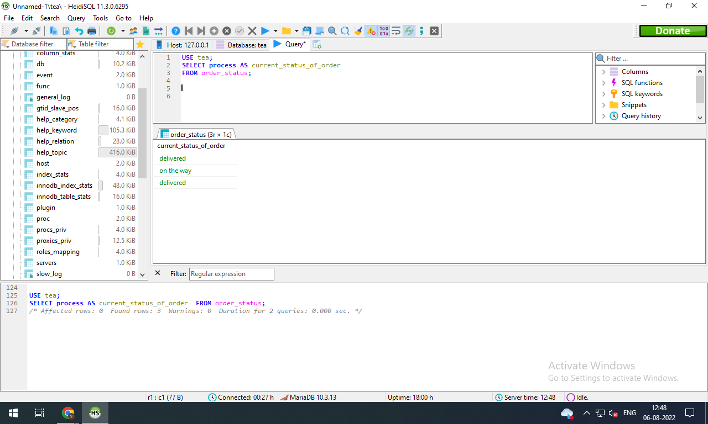

* 20 points for showing the query and the related screenshots (10 pairs of before and after)
* 10 pts for The query .sql file on GitHub containing all of the queries

Total points possible: 45

**WARNING:** Screen captures that just show an ‘ok’ message are NOT valid results. You must display the change to the database or the output of the query.

Also, I should be able to download your sql file and run it to confirm that the commands work.

**SECTION 3 – 20 points**

**Imagine you are ready to hire someone technical at your company to help administrate the database. Write a paragraph or two (less than a page) explaining what technical resources you need to develop to help your business grow with your database system in terms of**

**1) handling customer interactions**

**2) technical components such as language, language implementations, or anything else relevant**

**3) sales operations**

**4) administrative maintenance and operations**

**For example, how would a customer interact with the database? What software would you use and how would you implement it? Would you need a dedicated IT administrator? If not, how would you submit work requests? What would a salesperson do to add an order to the system?**

**There is no single correct answer to this challenge. I just want to see that you have a thought process and understand these concepts. Address each of the 4 talking points above in your report for a total of 20 points.**

**Answer-**

A Database administrator, who is an information technician and responsible for handling all the activities related to the database. The database administrator makes sure the company’s databases may operate efficiently and fuctionally. In my company, i would surely appoint database administrator who can look after the database management system of my company. In my company I would like to use Zendesk as a customer database software. It is a type of customer relationship management database software helps to reduce friction, to increase efficiency in the system. It can provide facilities like customizing reports, eliminate spreadsheets.

Customer can interact with us via online customer request portal. Here customer can get update of the activities which is most important. Customers may access changes to their knowledge base and community contributions, monitor the progress of their support requests, and track the information. Having a list of best practises for your sales operation strategy is advantageous. In my company i would appoint a person who can bridge the gap between marketing, sales, supply and demand. I will keep detailed records of each change you make and its results. I would identify the areas where th company needs an adjustment and later on, reevaluate as necessary. No amount of data planning will enhance efficiency unless the organisation encourages cross-departmental communication and collaboration. I would provide the working environment in the sales operations team for getting successful.